
BAKERSFIELD COLLEGE

DC Electronics

Raspberry Pi Pico

Project 01: Hello World

1. Introduction
For Raspberry Pi Pico beginners, we will start with some simple things. In this project, you only need a Raspberry Pi Pico and a USB cable to complete the "Hello World!" project, which is a test of communication between Raspberry Pi Pico and the PC as well as a primary project.

2. Wiring Up
In this project, we use a USB cable to connect the Raspberry Pi Pico to the computer.
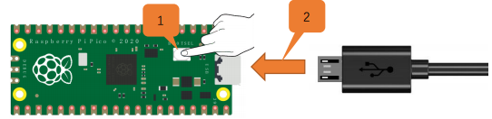

Raspberry Pi Pico USB Cable

3. Test Code
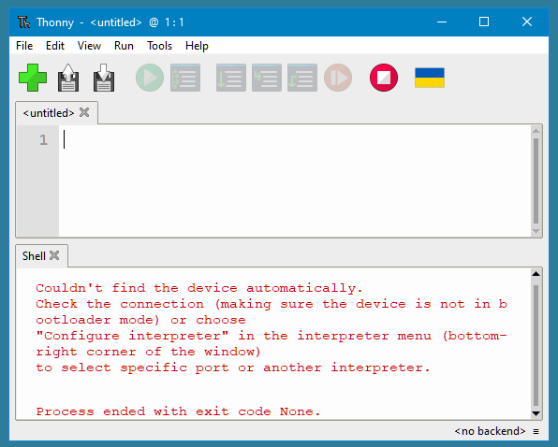
Connect the pico board to the PC, then open, Thonny is a free, easy and open-source integrated development environment (IDE) with Python built-in that is designed for us beginners to learn programming.

It supports compiling or debug programs.

In the "Shell" window, you can view the error information and output results generated during the running of your program, and you can query step-by-step expression evaluation, detailed visualization of the call stack and a mode for explaining the concepts of references and heap to help improve the compile program.

The Thonny (IDE) will be used for all the Raspberry Pi Pico – Projects.

When you first open ‘Thonny IDE’ it will look like this: (Because the Pi is not Plugged-in.)


After the Pi is Plugged-in click the: “Stop /Restart backend”

The ‘Thonny IDE’ will look like this: (Because the Pi is Plugged-in)
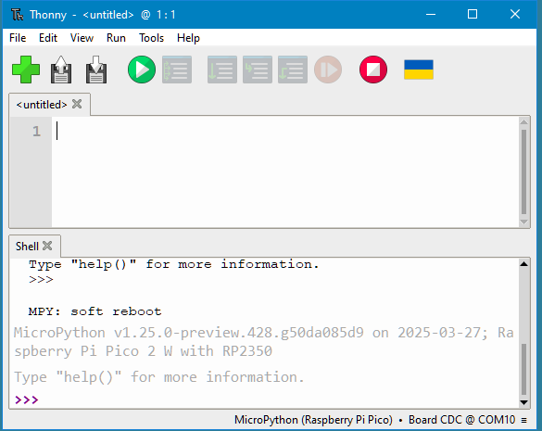

The ‘Thonny IDE’ it will display the Pi and the IDE with Python. ↑
At this point a program could be type-in or it can be loaded from a file.

Go ‘File’ then ‘Open’ or click “Open...”

Click ‘This computer’.

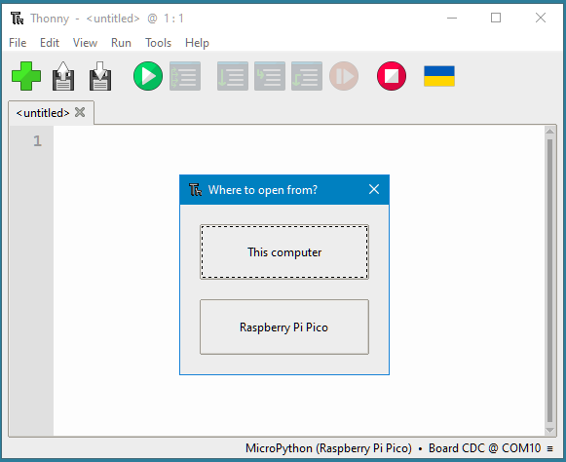

and choose the file to load. (#01 – Hello World.py)
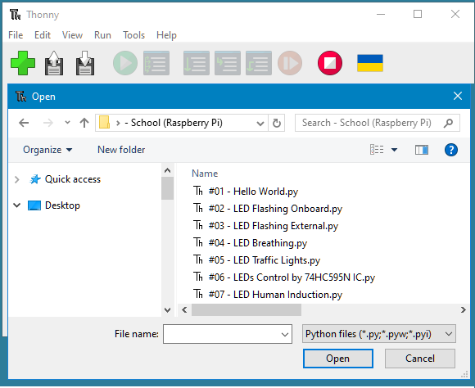

The IDE will look like this:

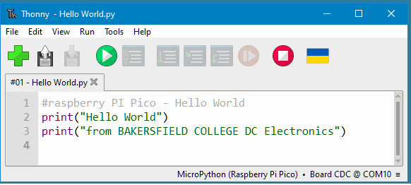


Now click the ‘Run’ then ‘Run current script’ or click the:
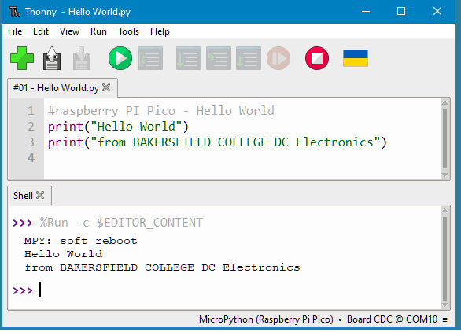

The bottom half (Shell X) of ‘Thonny’ will display the output.

